CMPEN 472, Homework 8 CodeWarrior Full Chip Simulator (Debugger) Guide

For this Homework, you will need both the Terminal window and two 7-segment displays in VisualizationTool of the CodeWarrior Simulator, as shown below.

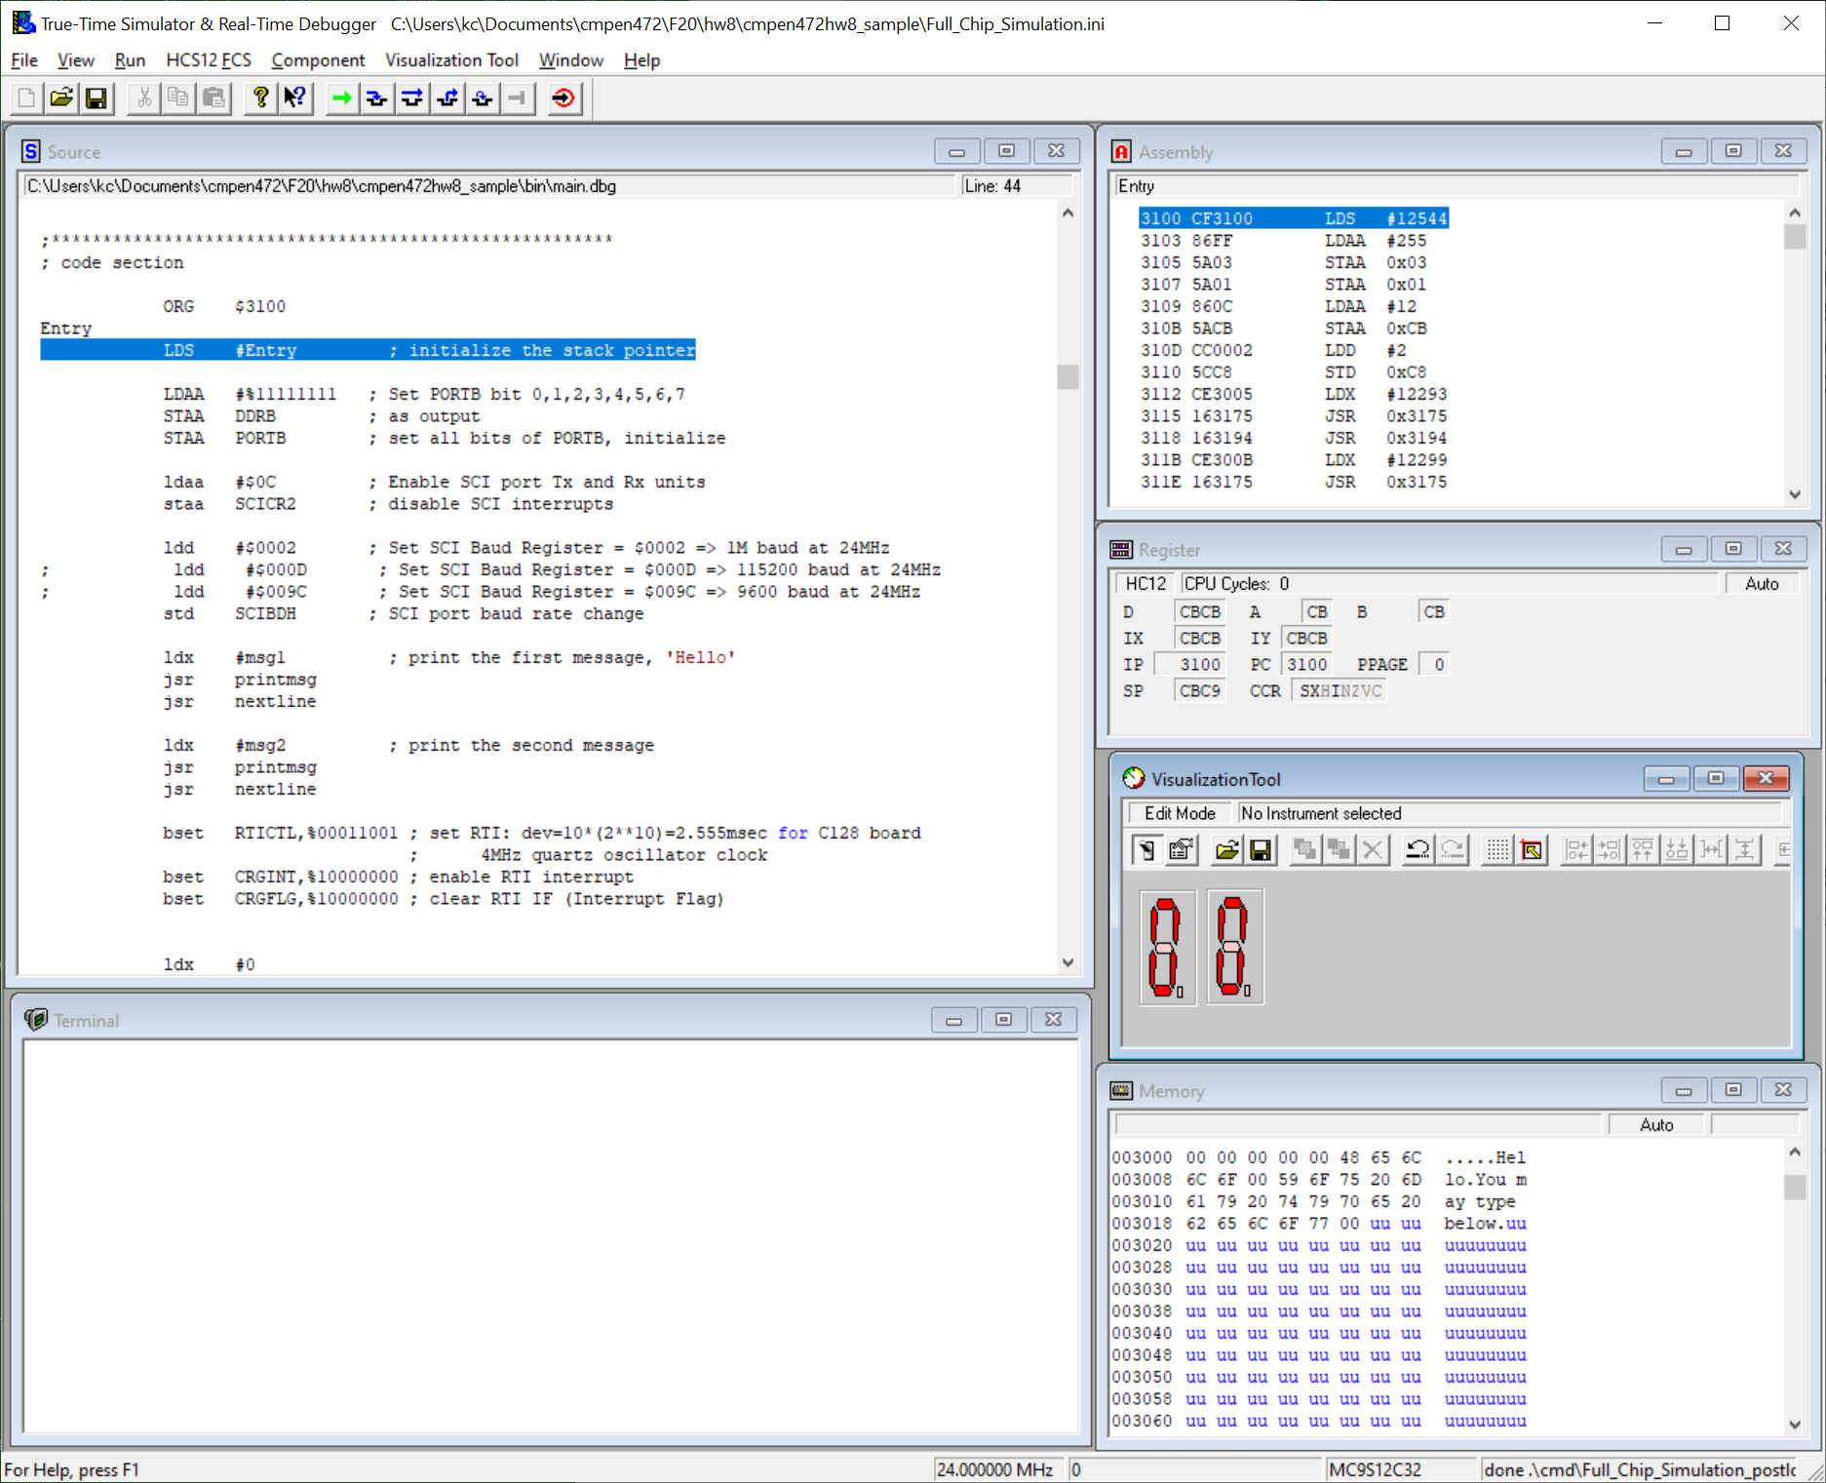

You may check the Homework 3 CodeWarrior Debugger/Simulator Aid. Also you may check the Homework 5 CodeWarrior Full Chip Simulator (Debugger) Guide, Step 3 – Terminal Component. Be sure to set the clock
at 24MHz, two 7-segment displays attached to PORTB, and the VisualizationTool Cycle Refresh Count set to 1 CPU cycle. And save your simulator configuration. Then, close the debugger and restart the debugger.

For the Homework 8 sample/example program: While the program is running on the simulator, you will be able to see the LED blinking and also you may be able to type into the Terminal window. What you type is what you see. You may stop simulation by clicking the ‘Halt’ button on the Debugger window.

You may change the LED blinking rate by (1) quit the Debugger. Then on your CodeWarrior window, (2)
change cpx #200 ; 2.5msec * 200 = 0.5 sec
to cpx #40 ; 2.5msec * 200 = 0.5 sec

Then (3) save your source file, and ‘Make’ and ‘Debug’

You may repeat this procedure to fine good speed as you debug your program.

